LED 2x4 Retrofit Kit
Lighting
Revision # 0

School EE Program
James Watkins

General Lighting
For Classrooms

At-a-Glance Summary

 | Measure 1 | Measure 2
Measure description | LED 2x4 Retrofit Kit
Program delivery method | Direct Install
Measure application type | Early Retirement
Base case description | 2/3/4 lamp T8/T12
Energy and demand impact common units | Per fixture
Peak Demand Reduction  (kW/unit) | 0.00018 to 0.09471
Energy savings  (Base case – Measure)  (kWh/unit) | 18.57 to 301.11
Gas savings  (Base case – Measure)  (therms/unit) | -4.0 to -0.038
Full measure cost  ($/unit) | N/A (Direct Install)
Incremental measure cost  ($/unit) | N/A (Direct Install)
Effective useful life  (years) | 12 years (DEER)
Net-to-gross ratio(s) | 0.85
Important comments

Document Revision History

Revision # | Revision Date | Section-by-Section Description of Revisions | Author (Name, PA)
0 | 3/20/2015 | New work paper | Yun Han

Commission Staff Review and Comment History

Revision # | Date Submitted to Commission Staff | Date Comments Received | Commission Staff Comments

Table of Contents
At-a-Glance Summary
Document Revision History
Table of Contents
Section 1. General Measure & Baseline Data
  - Product Measures
  - Program Implementation Overview
  - Product Parameter Data
Section 2. Calculation Methods
2.1 Program Implementation Analysis
2.2 Electric Energy Savings Estimation Methodologies
2.3 Demand Reduction Estimation Methodologies
2.4 Gas Energy Savings Estimation Methodologies
Section 3. Load Shapes
Section 4. Base Case, Measure, and Installation Costs
4.1 Base Case(s) Costs
4.2 Measure Case Costs
4.3 Installation/Labor Costs
4.4 Incremental & Full Measure Costs
Appendix 1 – Supplemental Files
Appendix 2 – Commission Staff Comments/Review
Appendix 3 – Measure Application Type Definitions
Appendix 4 – CPUC Quality Metrics
Appendix 5 – DEER Resources Flow Chart
References

General Measure & Baseline Data
  - Product Measures
General Description
This work paper details the retrofit of 2x4 interior T8 andT12 2/3/4-lamp linear fluorescent fixtures with 2x4 LED Luminaire Retrofit Kits. Linear fluorescent T12 fixture (F42EE) consists of energy saver lamps on a magnetic energy saver ballast, T8 32W fixture on a standard lamp and ballast (F42ILL), and T8 28W fixture on premium energy saver lamp and programmed rapid start ballast.

Table 1: Measures and Codes
Solution Code | Measure Name
LT-NEW7 | LED 2x4 Retrofit Kit Replacing 2-Lamp T8 28W
LT-NEW8 | LED 2x4 Retrofit Kit Replacing 3-Lamp T8 28W
LT-NEW9 | LED 2x4 Retrofit Kit Replacing 4-Lamp T8 28W
LT-NEW4 | LED 2x4 Retrofit Kit Replacing 2-Lamp T8 32W
LT-NEW5 | LED 2x4 Retrofit Kit Replacing 3-Lamp T8 32W
LT-NEW6 | LED 2x4 Retrofit Kit Replacing 4-Lamp T8 32W
LT-NEW1 | LED 2x4 Retrofit Kit Replacing 2-Lamp T12
LT-NEW2 | LED 2x4 Retrofit Kit Replacing 3-Lamp T12
LT-NEW3 | LED 2x4 Retrofit Kit Replacing 4-Lamp T12

Technical Description
2x4 LED Retrofit Kit is a kit designed to replace components of an existing linear fluorescent luminaire. The LED components consist of LED driver, modules (light source), mounting brackets, and MUST come with a lens to be installed as shown in Figure 1.

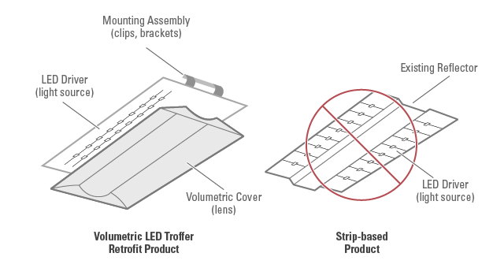
Figure 1 Typical LED Troffer Retrofit Kit Product

DLC’s 2x4 LED Retrofit Kit minimum criteria is shown below:

Lumens: 3,000
Spacing Criteria: 0-180°: 1.0-2.0, 90-270°: 1.0-2.0
Zonal Lumen Density: ≥75%: 0-60°
Efficacy: 85 lm/W
Allowable CCT: ≤5000 K
Minimum CRI: 80
L70 Lumen Maintenance: 50,000 hrs
Warranty: 5 years
  - Program Implementation Overview
Implementation Methods
The School Energy Efficiency Program (SEEP) will implement this measure in the following manner:

A trained program lighting auditor will identify the fixture where the retrofit kit will be installed, ensuring that the base case fixture falls within the identified parameters (as described above). The auditor will make sure that the fixture is functioning properly and will record the details of the existing fixture, along with baseline lighting level readings, taken at desk height. The auditor will also take photographs of the fixture, along with photographs of existing lamps and ballasts.

Dependent on the existing fixture type, the appropriate measure will be selected based on the existing number and type of lamps, and the corresponding retrofit kit will be selected for installation. At the time of installation, a trained program installer will install the identified retrofit kit according to the manufacturer specifications. Upon completion, the installer will test the fixture to ensure that it is functioning properly and will then take lighting level readings at desk height. The installer will provide the customer with a manufacturer specification sheet, along with warranty information for the retrofit kit. Post-installation inspections for quality and completeness of installation will be conducted by Southern California Edison representatives as determined by the contract program manager as described in the “Direct Install Program Comments” document in Appendix 1.

Program Restrictions and Guidelines
This measure applies to classrooms in Education – Primary School, Secondary School, and Relocatable Classroom.

Measure Application Type
These measures will be claimed as early retirement. The CPUC requirement that early retirement measures be supported by a preponderance of evidence is described in the “Direct Install Program Comments” document in Appendix 1, in which a trained lighting program auditor will ensure the existing fixture is working properly, record details of the existing fixture, and photograph the existing fixture, lamp, and ballast.

Implementation Requirements
To qualify for incentives, the LED Retrofit Kits must be listed on Design Light Consortium’s (DLC) Qualified Products List (QPL) [486], under the category “Retrofit Kits for 2x4 Luminaires for Ambient Lighting of Interior Commercial Spaces” and also be provided with a lens from the manufacturer. All existing interconnects, sockets, lens, and ballasts must be removed. The product must also have an integrated dimming capability to enable compliance with the Title 24 2013 standards. Additionally, as the measures in this work paper are specifically targeting a certain footcandle level, the qualifying products has been filtered as shown in the attachment.

  - Product Parameter Data
- DEER Data

Table 1. DEER Difference Summary
DEER | Used in Workpaper Approach?
Modified DEER methodology | No
Scaled DEER measure | No
DEER base case used | No
DEER measure case used | No
DEER building types Used | Yes
DEER operating hours used | Yes
Reason for Deviation from DEER | DEER does not contain this measure
DEER Version | N/A
DEER ID and Measure Name (Sample) | N/A

Net-to-Gross

Table 2. DEER Net-to-Gross Ratios
From DEER Tables
NTGR_ID | Description | Sector | Building Type | NTG | Program Delivery
All-Default<=2yrs | All other EEM with no evaluated NTGR; new technology in program for 2 or fewer years | All | Any | 0.7 | Any
Com-Default-HTR-di | All other EEM with no evaluated NTGR; direct install hard-to-reach only. | Com | Any | 0.85 | DirInstall
 | School NTG | Com | Schools | 0.85

Effective Useful Life / Remaining Useful Life

Table 3. DEER EUL Values/Methodology
READi EUL ID | Market | End Use | Measure | EUL (Years) | RUL (Years)
ILtg-Com-LED-50000hr | Commercial | Lighting | LED Fixture - Indoor- Commercial | 12 | 4

In-Service Rate / First Year Installation Rate:

Table 4. Installation Rate
From DEER Tables
GSIA_ID | Description | Sector | Building Type | GSIA Value | Program Delivery
Def-GSIA | Default GSIA values | Any | Any | 1 | Any

READi Technology Fields

Table 5. READi Tech IDs
READi Field Name | Values included in this workpaper
Measue Case UseCategory | Lighting
Measure Case UseSubCats | Indoor General Lighting
Measure Case TechGroups | Lighting - Fixtures
Measure Case TechTypes | LED Fixture
Base Case TechGroups | Lighting – Fixtures
Base Case TechTypes | Linear Fluorescent Fixture
- Codes & Standards Requirements Base Case and Measure Information
Title 24:
Title 24 2013 Section 141.0(b)2 contains codes related to Nonresidential lighting as shown below. The measures in this work paper do change the type of light source in a luminaire which triggers Luminaire Modifications-in-Place. Triggering Modifications-in-Place requires mandatory control provisions in Section 130.1(a)(b)(c)(d) for each enclosed space that includes Area, Shut-off, Multi-level, and if applicable, Daylighting Controls.

Lighting System Alterations shall meet the applicable requirements in TABLE 141.0-E and the following:
- Lighting System Alterations include alterations where an existing lighting system is modified, luminaires are replaced, or luminaires are disconnected from the circuit, removed and reinstalled, whether in the same location or installed elsewhere.
EXCEPTION 1 to Section 141.0(b)2Iii: Alterations that qualify as a Luminaire Modification-in-
Place.
EXCEPTION 2 to Section 141.0(b)2Iii: Portable luminaires, luminaires affixed to moveable partitions, and lighting excluded in accordance to Section 140.6(a)3.

Luminaire Modifications-in-Place shall meet the applicable requirements in TABLE 141.0-F and the following:
- To qualify as a Luminaire Modification-in-Place, luminaires shall only be modified by one or more of the following methods:
  - Replacing lamps and ballasts with like type or quantity in a manner that preserves the original luminaire listing.
  - Changing the number or type of light source in a luminaire including: socket renewal, removal or relocation of sockets or lampholders, and/or related wiring internal to the luminaire including the addition of safety disconnecting devices.
  - Changing the optical system of a luminaire in part or in whole.
  - Replacement of whole luminaires one for one in which the only electrical modification involves disconnecting the existing luminaire and reconnecting the replacement luminaire.
- Luminaire Modifications-In-Place shall include only alterations to lighting system meeting the following conditions:
  - Luminaire Modifications-in-Place shall not be part of or the result of any general remodeling or renovation of the enclosed space in which they are located.
  - Luminaire Modifications-in-Place shall not cause, be the result of, or involve any changes to the panelboard or branch circuit wiring, including line voltage switches, relays, contactors, dimmers and other control devices, providing power to the lighting system.

EXCEPTION to Section 141.0(b)2Iiii2. Circuit modifications strictly limited to the addition of occupancy or vacancy sensors and class two lighting controls are permitted for Luminaire
Modifications-in-Place
- Relevant EM&V Studies
N/A
- Relevant Workpaper Dispositions
2013-2014_LightingRetrofit_Disposition-30May2014 on Linear Fluorescent Code Baselines.
- Other Sources for non-DEER Methods
N/A
- Calculation Methods
  - Program Implementation Analysis
Table 6. Baseline by Measure Application Type
Measure Application Type | Baseline | Baseline Technology | Duration
ER | First | Linear Fluorescent Fixture | ER RUL = 15/3 = 5 years
 | Second | Standard LED 2x4 Retrofit Kit | ER EUL-RUL = 12-5 = 7
  - Electric Energy Savings Estimation Methodologies
The performance of the LED Retrofit Kit is based on the IES minimum standard for classrooms. The IES Lighting Handbook recommends horizontal illuminance target of 500 lux which equates to 46 footcandles. A classroom with a dimension of 30x30 feet (900 ft2), 10 foot ceiling height, and 12 fixtures per room was simulated as shown in Figure 2. Based on the results, the LED Retrofit Kits’ lumen output ranges from 3,900 to 4,200 lumens to provide average footcandles between 45 and 46, averaging 41 Watts per kit. The baseline wattage values are not greater than the LED wattages being installed. T12 and T8 fixtures provide average footcandles anywhere between 54 and 108.

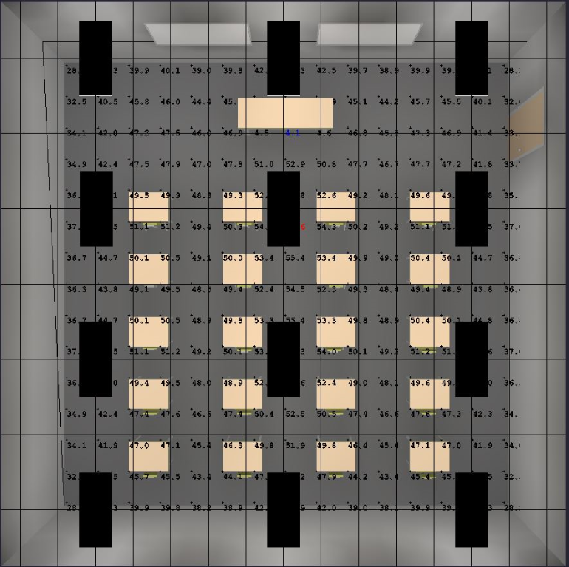
Figure 2 Classroom Simulation

The allowed lighting power density of a classroom is 1.2 Watts/ft². The proposed measure at an average of 41 Watts results in 0.54 Watts/ft² which according to Title 24 2013 is ≤85% of allowed lighting power per Section 140.6 Area Category Method. The multilevel lighting control is relaxed to an option of having “two level lighting control with at least one step between 30% and 70% of design lighting power in a manner providing reasonable uniform illuminations.”

The DEER methodology is shown by the equation below for both Energy Savings and Demand Reduction which factors in Interactive Effects and Coincident Diversity Factor using DEER provided operating hours.

First Baseline
The following is a sample energy savings calculation of RET 1st baseline for LED 2x4 Retrofit Kit Replacing 2-Lamp T12 in Education – Primary School building type in Climate Zone 6.

$$EnergySavings\left[\frac{kWh}{Unit×Year}\right]=\frac{\left(0.031\right)×\left(2135.2\right)×(1.1641)}{1,000\left(\frac{Watthours}{kWh}\right)}$$
$$EnergySavings\left[\frac{kWh}{Unit×Year}\right]=77.05$$

Second Baseline
The following is a sample energy savings calculation of RET 2nd baseline and ROB 1st baseline for LED 2x4 Retrofit Kit Replacing 2-Lamp T12 in Education – Primary School building type in Climate Zone 6. The code baseline for T12 is a 2nd generation T8. This calculation uses the occupancy sensor operating hours for the chosen building type to calculate the energy savings due to code.

$$EnergySavings\left[\frac{kWh}{Unit×Year}\right]=\frac{\left(0.018\right)×\left(1950.0\right)×(1.1641)}{1,000\left(\frac{Watthours}{kWh}\right)}$$
$$EnergySavings\left[\frac{kWh}{Unit×Year}\right]=40.86$$

  - Demand Reduction Estimation Methodologies
First Baseline
The following is a sample demand reduction calculation of RET 1st baseline for LED 2x4 Retrofit Kit Replacing 2-Lamp T12 in Education – Primary School building type in Climate Zone 6.

$$DemandReduction\left[\frac{kW}{Unit}\right]=\frac{(0.031)×(0.61448)×(1.2977)}{1,000\left(\frac{Watthours}{kWh}\right)}$$
$$DemandReduction\left[\frac{kW}{Unit}\right]=0.02472$$

Second Baseline
The following is a sample demand reduction calculation of RET 2nd baseline and ROB 1st baseline for LED 2x4 Retrofit Kit Replacing 2-Lamp T12 in Education – Primary School building type in Climate Zone 6. The code baseline for T12 is a 2nd generation T8. This calculation uses the occupancy sensor coincident diversity factor for the chosen building type to calculate the energy savings due to code.

$$DemandReduction\left[\frac{kW}{Unit}\right]=\frac{\left(0.018\right)×\left(0.55113\right)×(1.2977)}{1,000\left(\frac{Watthours}{kWh}\right)}$$
$$DemandReduction\left[\frac{kW}{Unit}\right]=0.01287$$
- Load Shapes
The difference between the base case load shape and the measure load shape would be the most appropriate load shape; however, only end-use profiles are available. Therefore, the closest load shape chosen for this measure is the DEER:Indoor_Non-CFL_Ltg load shape. See table below for a list of all Building Types and Load Shapes. See the KEMA report [31] for a more thorough discussion regarding the load shapes for this measure.

Table 7. Building Types and Load Shapes
Building Type | E3 Alternate Building Type | Load Shape
Education - Primary School | NON_RES | DEER:Indoor_Non-CFL_Ltg
Education - Secondary School | NON_RES | DEER:Indoor_Non-CFL_Ltg
Education - Relocatable Classroom | NON_RES | DEER:Indoor_Non-CFL_Ltg

- Base Case, Measure, and Installation Costs
For Direct Install measures, SCE directly utilizes one or more contractors as part of the program. The actual cost can vary by contractor, the date in which the work occurred, and by the volume of business. Contractor costs are confidential information and are based upon contractually agreed upon pricing as established in their purchase order with SCE; therefore, the SCE program tracking system is the only source for this data.
- Additional Data Needs
  - Interim Workpaper Status

If applicable, describe reasons for, and duration of, interim approval of this workpaper. Describe additional data or information required to receive regular approval of the workpaper, and the timing associated with procuring the additional information.
  - Data Collection Needs
- Implementation

Describe data that must be collected during implementation either for the purposes of an interim workpaper, for future analysis, for measure expansion, etc. Describe
- how and when data will be collected, and by whom
- whether implementation data collection is confirmed or to be determined.
- Measurement and Evaluation

Describe data that should be collected through measurement and evaluation and why.

Appendix 1 - Supplemental Files

Appendix 2 – Commission Staff Comments / Review

Include embedded file(s) with Commission staff feedback.

Appendix 3 - Measure Application Type Definitions

The DEER Measure Cost Data Users Guide found on www.deeresources.com under DEER2011 Database Format hyperlink, DEER2011 for 13-14, spreadsheet SPTdata_format-V0.97.xls, defines the measure application type terms as follows:

Measure Application Type
Code | Description | Comment
ER | Early retirement | Measure applied while existing equipment still viable, or retrofit of existing equipment
EAR | Retrofit Add-on | Retrofit to existing equipment without replacement
ROB | Replace on Burnout | Measure applied when existing equipment fails or maintenance requires replacement
NC | New Construction | Measure applied during construction design phase as an alternative to a code-compliant standard design

Baseline Technologies for UES and Cost calculations
Measure Application Type | Baseline | Baseline Technology | Measure Cost Calculation | Duration
ER | First | Existing technology | Measure equipment cost + labor cost | RUL = 1/3*EUL
 | Second | Code or standard | (-1)*(Code/standard equipment cost + labor cost) | EUL - RUL
REA | First | Existing technology | Measure equipment cost + labor cost | EUL
 | Second | N/A | N/A | N/A
ROB | First | Code or standard | (Measure equipment cost + labor cost) – (Code/standard cost + labor cost) | Full EUL
 | Second | N/A | N/A | N/A
NC | First | Code or standard | (Measure equipment cost + labor cost) – (Code/standard cost + labor cost) | Full EUL
 | Second | N/A | N/A | N/A

Measure cost overview developed by SCE:

Appendix 4 – CPUC Quality Metrics
CPUC workpaper development actions to ensure quality are listed below, adapted from ex ante implementation scoring metrics described in Attachment 7 of Decision (D).13-09-023. The corresponding scoring metrics are shown below.
Metric | Workpaper Development Action to Ensure Quality
2 | Address all aspects of the Uniform Workpaper Template
3a | Include appropriate program implementation background
3b | Include analysis of how implementation approach influences development of ex ante values
3c | Include all applicable supporting materials
3d | Include an adequate description of assumptions or calculation methods
4 | Pursue up-front collaboration on high impact measures with Commission staff prior to formal submission for review
7 | Include analysis of recent and relevant existing data and projects that are applicable to workpaper technologies for parameter development that reflects professional care, expertise, and experience
9 | Appropriately incorporate DEER assumptions, methods, and values for new or modified existing measures using professional care and expertise
10 | Incorporate cumulative experience into workpaper through inclusion of an analysis of previous activities, reviews, and direction. (ED expects IOUs to immediately incorporate disposition guidance into workpapers to be submitted for formal review)

Appendix 5 – DEER Resources Flow Chart

References

Full measure cost = measure equipment cost + measure labor cost
Incremental measure cost = Measure equipment cost – Baseline equipment cost
According to the Energy Efficiency Policy Manual v.5 at page 32, the measure cost for an early-retirement case is “the full cost incurred to install the new high-efficiency measure or project, reduced by the net present value of the full cost that would have been incurred to install the standard efficiency second baseline equipment at the end of the [RUL] period”. Page 33 elaborates that “the period between the RUL and EUL defines the second baseline calculation period…the measure cost for this period is the full cost of equipment, including installation, for the second baseline equipment measure”.
The Energy Efficiency Policy Manual v.5 at page 33 states “the remaining useful life (RUL)…[is established by DEER] as one-third of the expected useful life (EUL) for the equipment type”.
The Uniform Workpaper Template is not posted on the DEER website as of 4/21/14, and is currently in Microsoft Access Database format.
Metric 3 is not split among a – d in Attachment 7, however metric 3 was separated into four subcategories in this document for the purposes of identifying individual workpaper development actions to address quality.
“Adequate” is defined in Attachment 7 such that derivations of underlying assumptions of workpaper are easy to understand by the CPUC reviewer.
IES Handbook 10th Edition Table 24.2
Calculations

