|  |  |
| --- | --- |
| Date: | June 9, 2023 |
| To: | Energy Efficiency Program Administrators |
| From: | Ayad Al-Shaikh, Principal Engineer, California Technical Forum |
| Subject: | Cost Effectiveness Analysis of New Construction Gas Measures Pursuant to D.23-04-035 OP2 |

# Executive Summary

This report summarizes the results of a series of technical meetings held with California Energy Efficiency Program Administrators and facilitated by the California Technical Forum staff. These meetings were held to develop a consistent approach and set of assumptions for completing cost effectiveness analysis of new construction gas measures and complete the analysis necessary to comply with D.23-04-035 OP2, which states:

“Within 60 days after the issue date of this decision, the program administrator lead for each non-exempt natural gas new construction measure, whether it is [list of each PA], must file a document that identifies the Total Resource Cost benefit to cost ratio (based on the Cost Effectiveness Tool) for each deemed electronic Technical Reference Manual measure package permutation of non-exempt natural gas new construction measures with all available known costs. For administrative costs, the program administrators must agree on a consistent approach, either to use an average of administrative costs or to use the lowest of all program administrators’ administrative costs to calculate the Total Resource Cost benefit to cost ratio.”

Completion of this analysis involved three main steps:

* Identifying non-exempt gas measure permutations
* Approach to allocation of Admin Costs
* Assumptions and methodology for calculating Total Resource Cost (TRC)

Results of this analysis are included in the attached file named “Nonexempt Permutation TRC Analysis (D.23-04-035).xlsb”, and instructions for accessing a dashboard summarizing this data have been provided in the body of the report.

In accordance with OP2, the group identified the gas measures that should be considered “non-exempt” and reached agreement on how to apply administrative costs to the TRC calculation. This methodology is outlined below. An area where alignment was not necessarily reached was the level of incentives to incorporate into the methodology. Consequently, the methodology below presents two analysis scenarios: No incentives and Incentives set at 50% of incremental measure cost (IMC). Furthermore, the team performed additional analysis on incentive levels between 0 and 50% that calculates the impact of differing incentive levels on the number of measure permutations that remain eligible for incentives.

The team agreed that further review and recommendations of the appropriate incentive scenario was out of scope for this Cal TF team, and affected PAs would address this topic with their respective policy groups.

# Approach to identifying non-exempt permutations

eTRM data was utilized to identify all measure packages that could contain non-exempt permutations through a Measure Report that was generated in May 2023. The basis for our decision process to identify non-exempt measures came from the definition of an “ ‘exempt measure’ - measures that result in gas savings but do not burn gas”. Therefore, we categorized “non-exempt measures” (e.g., furnace – since it saves gas but also burns gas), “exempt measures” (e.g. showerhead – since it saves gas but does not burn gas), and “not applicable” (e.g., a light bulb or a heat pump – since these are electric products that don’t burn gas). Two additional details were included in this process:

* Some measure packages (MP) that do not save gas may still burn gas (e.g., packaged AC). These MPs were included within the non-exempt category.
* Some MPs are not exclusively exempt, non-exempt, or not applicable. (e.g., the Commercial Griddle MP, SWFS004-01, includes offerings that are both gas, which are non-exempt, and electric, which are not applicable).

This list of non-exempt offerings constituted the set of permutations that were calculated for Total Resource Cost benefit to cost ratio. This list can be found in the file:

* File: “Nonexempt gas measures – CET output.xlsx
* Worksheet: “Measure Offering List”

# Approach to allocation of Admin Cost

There are many practical challenges associated with accurately allocating administrative costs to programs and measures, which become increasingly difficult when allocating admin costs to measure permutations in eTRM. By default, administrative costs are not inherently attributable to measures, and measure permutations in eTRM represent values that are allowable for claims and forecasts but may not necessarily be used in actual claims or forecasts.

PAs discussed several approaches to estimate how admin costs could reasonably be applied to permutations with a group that included:

* Pacific Gas and Electric Company,
* San Diego Gas & Electric Company,
* Southern California Edison Company,
* Southern California Gas Company,
* Bay Area Regional Energy Network,
* Southern California Regional Energy Network,
* Tri-County Regional Energy Network,
* Inland Regional Energy Network, or
* Marin Clean Energy

Below is a list of variables and/or decisions that were made to determine the proposed values:

**Unit Admin Cost Basis:**

**Numerator**: PAs decided that for this analysis, it was most appropriate to use admin costs from recent claims data (2022 Claims as of May 22, 2023).

**Denominator**: The method for allocating admin costs that was selected for this proposal is per unit total system benefit (TSB). Several options were discussed, including Admin-Cost/Gross Measure Cost and dividing admin costs across kWh and Thm savings (Admin-Cost/kWh + Admin/Thm). These options, while they have potential merit, were not selected because the total system benefit method most directly aligns with the method the Cost Effectiveness Tool uses to allocate program costs to individual measures.

The admin cost used in this analysis is the sum of all program costs from the claims data that could include Admin Costs Overhead and GA, Admin Costs Other, Marketing Outreach, Direct Install Activity, Direct Install Installation, Direct Install Hardware and Materials, Direct Install Rebate and Inspection, EMV, User Input Incentive, or Costs Recovered From Other Sources.

Scope:

* + PA: RENs were excluded from this analysis as they do not have a minimum cost effectiveness threshold, and this effort is focused on New Construction and Resource Acquisition (neither of which are a primary focus for RENs).
  + Sector: All available sectors from claim "Program Sector" were included, with results summarized by Program Sector.
  + Segment: Resource Acquisition only, there is no cost effectiveness criterion for Market Support or Equity; and this phase of the gas phaseout only applies to the Resource Acquisition segment. Codes and Standards is also excluded. Note that Segment was downloaded separately from CEDARS since it does not appear directly in the claims data (https://cedars.sound-data.com/programs/list/), and then it was applied to claims using the Program ID.
  + Measure Application Type: All MATs were included except for BROs and Accelerated Replacement. BROs are inherently different from EE equipment, can have zero measure cost, and are also "exempt" measures; Accelerated Replacement by definition does not apply to New Construction.
  + Measure Impact Type: Only Deemed EE measures were included for this analysis, as the initial phaseout and OP2 task only apply to deemed EE measures (i.e. this analysis excludes fuel substitution measures, NMEC, and custom measures).
  + Use-Category: Measures identified as a "Non-Savings Measure" were excluded from this analysis.

**Average or Lowest**: OP2 requires the PAs to choose either the average admin cost or the lowest across PAs. Admin costs vary across the PAs and across sectors. SoCalGas, which is presumably the PA that will be most impacted by gas appliance phase out, has the minimum admin costs at the portfolio level. Using the minimum value helps to ensure that we are not excluding a permutation if a PA can deliver it cost effectively. The PAs generally agreed to pursue an approach that determines admin costs by sector, and selected the lowest of each sector (SCE expressed a preference for using an average value but did not oppose using a minimum). The difference in program cost between Res and Non-Res sectors is significant enough that it should be separated without complicating the analysis unnecessarily. Before selecting the final values, it was confirmed that the values used to form the minimum admin cost per sector were of a sufficient scale to reasonably represent PA admin costs.



**Results for calculating Admin Cost:**



# Approach to calculating Total Resource Cost benefit

**Permutation Data Source**: All permutation data was taken directly from the eTRM for each of the non-exempt offerings that were identified by the working group; this data will be referred to as the permutation set. The eTRM can create the Measure.csv file needed to run the CET on the CEDARS website. This data was used directly from the eTRM data extracted in May 2023 except for the following changes.

**Updated Admin Cost**

Using the methodology described above, Admin Cost was calculated at the permutation level using the approach of $/TSB that varies only by program sector.

*Step 1 – Calculating TSB with correct Avoided Cost data:* Since the original $/TSB factors were calculated using 2022 claims, which use 2021 avoided cost data, these factors should be applied to TSB values that are also calculated using 2021 avoided cost data. Therefore, the permutation set was run within the newly released CET tool (released 5/17/2023) using 2021 avoided cost data with these inputs:



The output from this CET run will produce TSB (net) values for each permutation. In this way, Admin Cost can be calculated at the permutation level by multiplying TSB ($) by the factor (Admin Cost($) / TSB($)) based upon the appropriate sector.

*Step 2 – Calculating TRC with updated Admin Cost*: Admin cost is populated ProgramCost.csv file by aligning one program entry for every measure entry. This alignment avoids admin costs being redistributed across permutation.

*Step 2a – No Incentive*: Incentive was kept at zero for this run. Since incentives are not a known cost, they were not included in the result. This CET run used 2024 Avoided Cost data with these inputs:



*Step 2b – Incentive calculated at 50% of the IMC*: As an alternative, incentives were calculated to be 50% of the incremental measure cost (IMC). Since this analysis focuses on New Construction measure application types, IMC is equivalent to the first baseline cost. The same set of CET inputs was used to run this analysis.

*Step 3 – Incentive inflection value to make TRC = 1*: To clarify the relationship that incentive has on TRC, the incentive amount (as a percentage of IMC) that results in a TRC = 1 was calculated from the basic TRC equation:

The histogram below shows the number of permutations that increasingly fall below the TRC=1 level as incentive increases. For example, the 0-5% bin shows that 886 additional nonexempt permutations drop below TRC=1 when the incentive is estimated to be between 0 and 5% of IMC. Similarly, the 5-10% bin shows that 942 more nonexempt permutations (in addition to the previous bin) drop below the TRC=1 level.

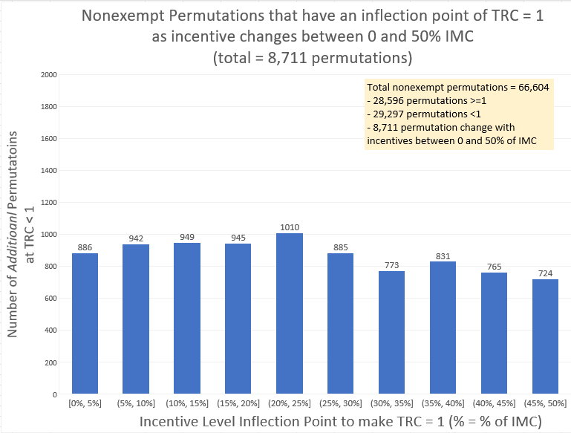

**Data Visualization:**

The following link helps to visualize this data:

[*PowerBI Link to TRC Data*](https://app.powerbi.com/view?r=eyJrIjoiMTZiNmM0M2YtNDM2MC00YmViLWJlMzgtODY3ZTgwNzMxMjMzIiwidCI6ImM5YThiODcwLWM2YzMtNDNjMy1iNzg2LTkxODEyZmRmNjcwOCJ9)

3 TRC Range Columns:

* + TRC < 0.7
  + 0.7 >= TRC < 1.0
  + TRC >= 1.0

3 TRC Level Row Categories: (see totals at the bottom)

* + **Red Rows**: >95% of permutations are less than 1.0
  + **Green Rows**: >95% of permutations are greater than 1.0
  + **No Color Rows**: Mix of values above and below 1.0

TRC Values calculated: (see RunType filter, at the bottom)

* + With no incentive to others
  + With incentive to other calculated as 50% of the incremental measure cost

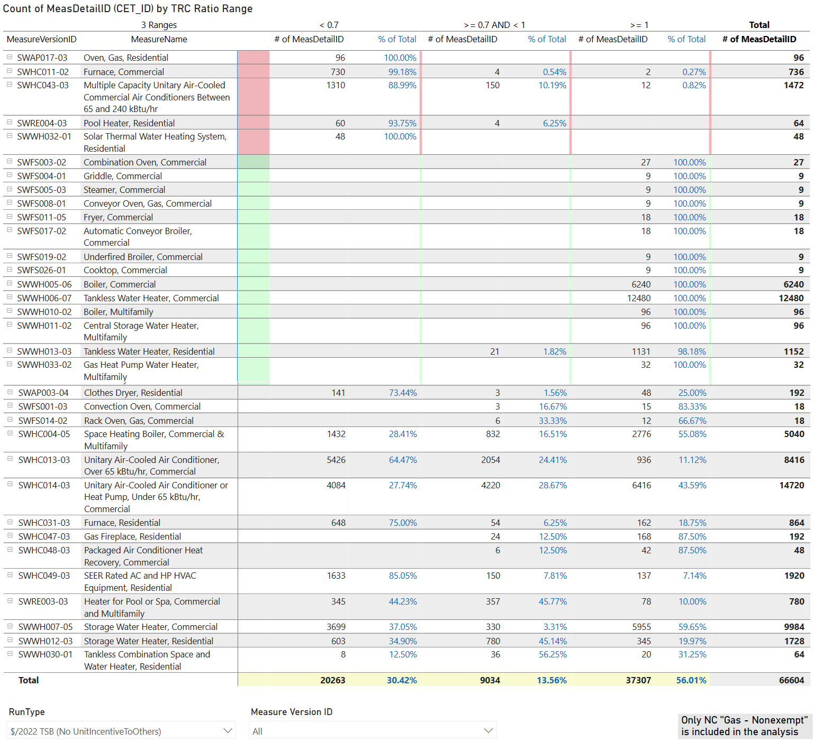

Data can be drilled into more deeply using the feature (right click on Measure Version ID, see the image below) Drill through -> By OfferingID-BldgType-E3ClimateZone

In this detailed view, data can be visualized to compare TRC by Building Type, Climate Zone and Offering to understand the variety that might exist.

